**Aim:**

To develop and design a mobile web application to change the background colour and menu.

**Procedure:** 1.start a new file and set up a frame size of 360*640 (Android small).

2.Draw a background rectangle and apply color or image.

3.Create a small rectangle box and text box for get started and place it in centre.

4.place a image within circle using image tool or by dragging and dropping an image.

5.use the rectangle tool to draw input fields for email , username , password. Add placeholders text in each field.

6.Draw a login button with rectangle below the text fields and style it with color and effect.the

Before background change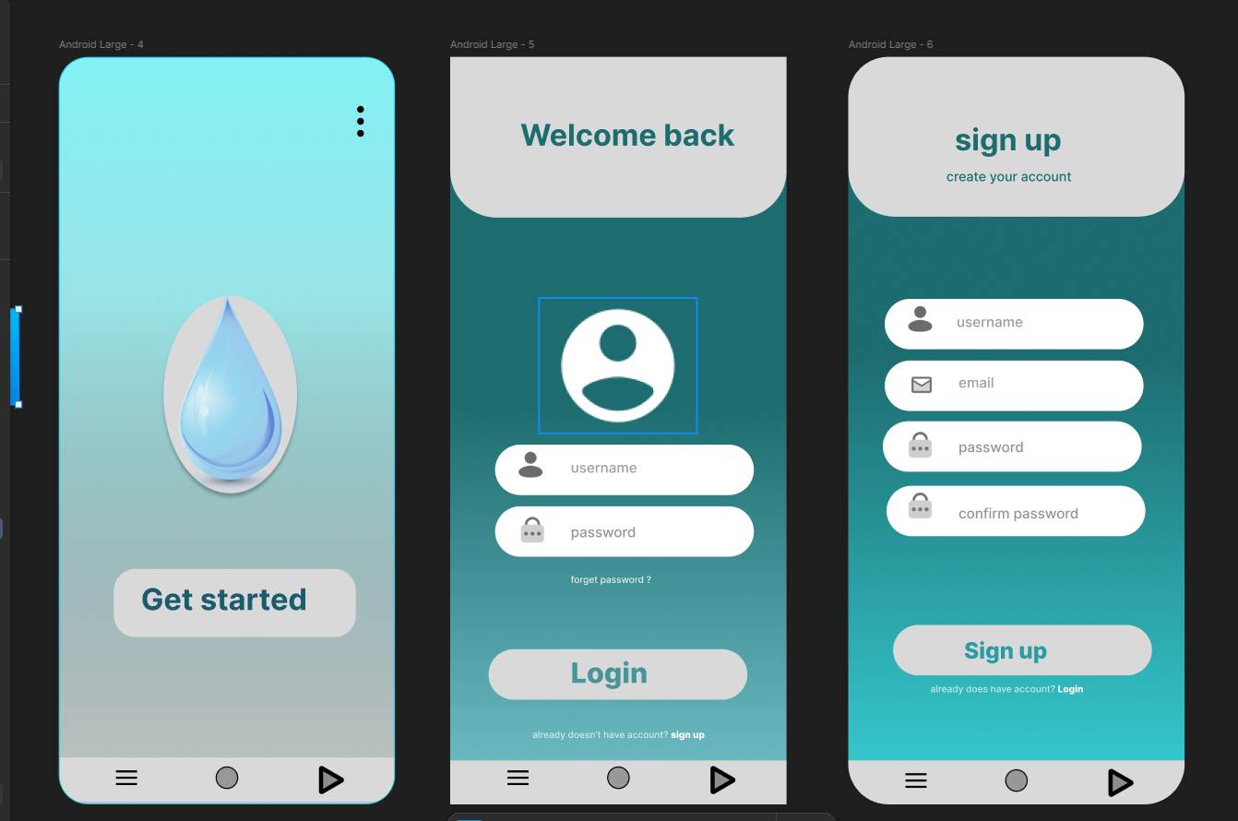

After background change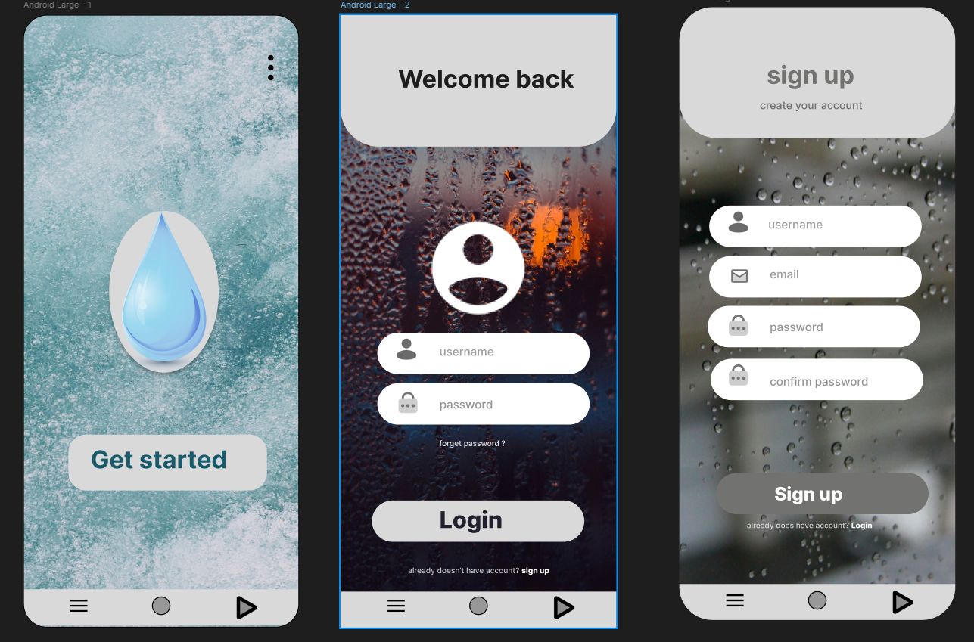

**Result:**

The Design of mobile web application to change the background colour and menu is developed.